Enable Fixed Asset
- Go to Administration > System Initialization > Company Details > Basic Initialization tab
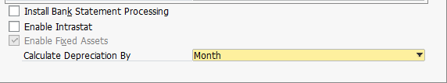

- Select the checkbox Enable Fixed Assets.
- Select “Month” from the dropdown list. *Cant disable after enabled

Month = (Cost – Salvage Value) / Useful Life
Day = (Cost – Salvage Value)/ (Useful Life / 12*365)

